# Appraisal Template

To be used alongside the [Annual Appraisal Guidance](https://nhs.sharepoint.com/sites/HRandOD/SitePages/new-approach-to-1to1-and-appraisal.aspx?csf=1&web=1&e=yQqxv8&ovuser=37c354b2-85b0-47f5-b222-07b48d774ee3%2Crebecca.dale15%40nhs.net&CID=49dc58a1-204a-a000-40c0-4b96c89310bf&cidOR=SPO&OR=Teams-HL&CT=1728655037528&clickparams=eyJBcHBOYW1lIjoiVGVhbXMtRGVza3RvcCIsIkFwcFZlcnNpb24iOiI0OS8yNDA5MTIyMTMwOSIsIkhhc0ZlZGVyYXRlZFVzZXIiOmZhbHNlfQ%3D%3D#annual-appraisal)

**Employee name:**

**Line manager name:**

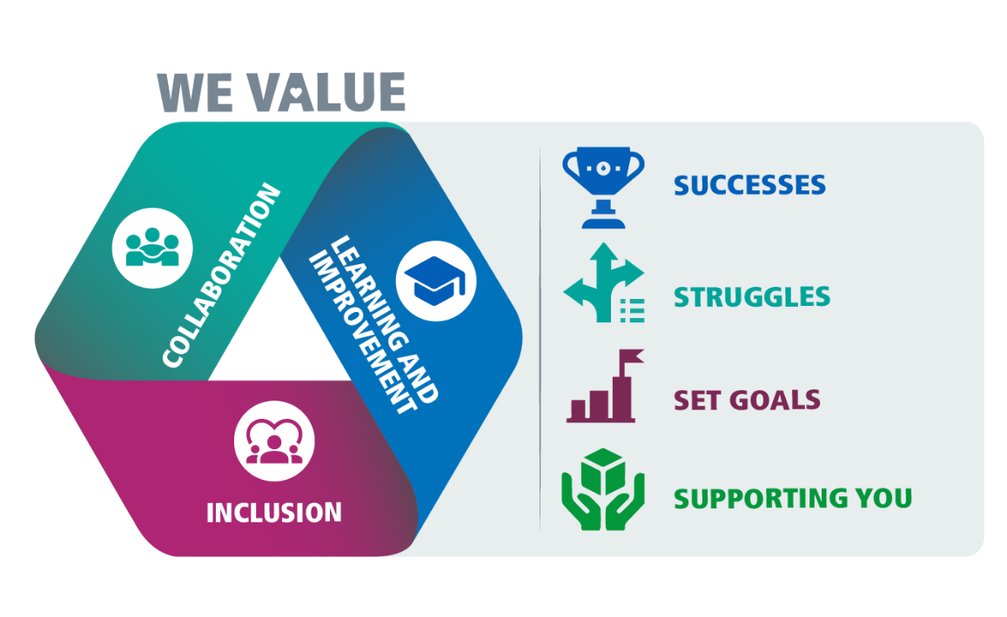**Date of appraisal:** Click or tap to enter a date.

Contents

Appraisal Template 1

**Successes 3**

What are your key successes or achievements? What are you proud of? 3

How did you achieve these successes? 3

**Struggles 4**

What have you struggled with? Are there any goals you have not met? Are there things that could have gone better? 4

How or why did you struggle? 4

**Set goals 5**

Please set around 5 goals - these should include both strategic and personal development goals for the next 12 months. 5

Goal 1 6

Goal 2 7

Goal 3 8

Goal 4 9

Goal 5 10

**Supporting you 11**

What support do you need to achieve your goals? 11

How can we help? 11

**Personal Development Plan 12**

1.Competency or skills area 12

2.Competency or skills area 13

3.Competency or skills area 14

**Corporate Compliance 15**

**Final reflection 15**

## Successes

### What are your key successes or achievements? What are you proud of?

1. Click or tap here to enter text.

### How did you achieve these successes?

**Discussion prompts**

* How did your skills help you to achieve your successes?
* How did your strengths help you to achieve your successes?
* What contribution have you made to improving Equality and Diversity?
* How did it help living up to our values: collaboration, inclusion, learning & improvement?

Notes: This is a good opportunity to celebrate successes. You could use the [ABC of appreciation model.](https://nhs.sharepoint.com/sites/HRandOD/SitePages/Supporting-tools-and-guidance-for-performance-conversations.aspx?csf=1&web=1&e=5PM926&ovuser=37c354b2-85b0-47f5-b222-07b48d774ee3%2crebecca.dale15%40nhs.net&OR=Teams-HL&CT=1727939776987&clickparams=eyJBcHBOYW1lIjoiVGVhbXMtRGVza3RvcCIsIkFwcFZlcnNpb24iOiI0OS8yNDA4MTcwMDQyMSIsIkhhc0ZlZGVyYXRlZFVzZXIiOmZhbHNlfQ%3D%3D&CID=963656a1-e092-9000-de3a-209276279f6c&cidOR=SPO" \l "recover)

## Struggles

### What have you struggled with? Are there any goals you have not met? Are there things that could have gone better?

Click or tap here to enter text.

### How or why did you struggle?

Click or tap here to enter text.

**Discussion prompt questions:**

* How do you think this happened?
* Why do you feel you struggled? (personal or external factors)
* Is there anything I could have done to support you more?
* Are there any gaps in skills, knowledge and experience or areas for development that contributed to this?
* Are there times where your strengths went into overdrive or didn’t help you?
* Were there any Equality and Diversity issues that contributed to this?
* Are there examples of when you or others struggled to live up to our values or they presented a barrier?
* What learning have you taken from this and what would you differently next time??

Notes: Provide constructive feedback on the individuals struggles to support development. You may want to use the [BUILD Model.](https://nhs.sharepoint.com/sites/HRandOD/Shared%20Documents/Learning%20and%20Development/Supporting%20tools%20and%20guidance%20for%20performance%20conversations%20(sharepoint.com))

If the examples indicate that the individual is experiencing a dip in performance or underperforming, please use the dedicated guidance (link coming soon) to support your discussion and next steps.

## Set goals

### Please set around 5 goals - these should include both strategic and personal development goals for the next 12 months.

* **What** will you achieve? Be specific about outcomes
* **Why** is the goal important to you or the organisation?
* **How** will you achieve it?
* **When** will you have delivered this?
* **Measure** – how will you know you have achieved it?

**Discussion prompt questions:**

* Do you have any skills gaps or development areas that you need to fill to support you to achieve your goals?
* How are you going to use and/or develop your personal strengths to help you to achieve your goals?
* How can you support Equality and Diversity whilst achieving your goals?
* How can you live our values whilst achieving goals? How can they be used to support success?
* How can your goals contribute to building a better NHSE and our commitment to creating a safe and inclusive environment and to continuous improvement?

### Goal 1

**What**

Click or tap here to enter text.

**Why**

Click or tap here to enter text.

**How**

Click or tap here to enter text.

**When**

Click or tap here to enter text.

**Measure**

Click or tap here to enter text.

### Goal 2

**What**

Click or tap here to enter text.

**Why**

Click or tap here to enter text.

**How**

Click or tap here to enter text.

**When**

Click or tap here to enter text.

**Measure**

Click or tap here to enter text.

### Goal 3

**What**

Click or tap here to enter text.

**Why**

Click or tap here to enter text.

**How**

Click or tap here to enter text.

**When**

Click or tap here to enter text.

**Measure**

Click or tap here to enter text.

### Goal 4

**What**

Click or tap here to enter text.

**Why**

Click or tap here to enter text.

**How**

Click or tap here to enter text.

**When**

Click or tap here to enter text.

**Measure**

Click or tap here to enter text.

### Goal 5

**What**

Click or tap here to enter text.

**Why**

Click or tap here to enter text.

**How**

Click or tap here to enter text.

**When**

Click or tap here to enter text.

**Measure**

Click or tap here to enter text.

## Supporting you

### What support do you need to achieve your goals?

Click or tap here to enter text.

### How can we help?

Click or tap here to enter text.

**Discussion prompts:**

Do you have any development needs?

Do you need any other support?

What can the organisation do to help you to meet your goals and development needs?

How is your wellbeing at work?

What can we do together to support you with it?

What can the organisation do to support your health and wellbeing?

Would you like to have a further discussion focussed on your career aspirations?

## Personal Development Plan

### 1.Competency or skills area

Click or tap here to enter text.

**Development need**

Click or tap here to enter text.

**How this will be met**

Click or tap here to enter text.

**Target date for completion**

Click or tap here to enter text.

### 2.Competency or skills area

Click or tap here to enter text.

**Development need**

Click or tap here to enter text.

**How will this be met**

Click or tap here to enter text.

**Target date for completion**

Click or tap here to enter text.

### 3.Competency or skills area

Click or tap here to enter text.

**Development need**

Click or tap here to enter text.

**How will this be met**

Click or tap here to enter text.

**Target date for completion**

Click or tap here to enter text.

## Corporate Compliance

Consider the following areas and, *where applicable*, confirm that appropriate action(s) have been completed.

**ESR** personal details up to date

**Mandatory and Statutory training (MAST) completed**

**Continuous Professional Development**

**Line Management Development Programme attendance**

**DBS completed**

**Professional Registration and Fitness to Practice** up to date on ESR

**Declaration of Interest completed**

**Workplace adjustments reviewed**

**Hybrid working office attendance expectation**

**Informal flexible working** arrangements reviewed

**Formal flexible working** arrangements (to be reviewed after the first year)

**NHS IMPACT E-learning completed**

## Final reflection

Please make sure that you allow time at the end of the conversation to pause, take a step back and share some final thoughts and reflections about the discussion that has just taken place.

Click or tap here to enter text.