Model Release Form

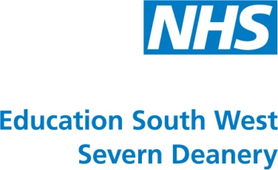

I hereby consent to the use of photographs of myself taken by doctors from the Severn Deanery.

I agree that the photographs taken of me may be used by the Severn Deanery as publicity material.

I hereby release and discharge the Severn Deanery from any and all claims and demands arising out of or in connection with the use of the photographs, including without limitation any and all claims for invasion of privacy, right of publicity, and defamation.

I have read this model release form carefully and fully understand its meanings and implications. This release shall be binding upon me, my heirs, legal representatives, and assigns.

No modification of this agreement shall be of any effect unless it is made in writing and signed by all of the parties to the agreement.

Signed: ……………………………………………………………………

Name (printed): ………………………………………………………….

Address: ………………………………………………………………….

……………………………………………………………………………..

Date……………………………………………………………………….

**Important**

If the model is under 18 years of age, a parent or legal guardian must also sign below.

Parent/Guardian signature: ……………………………………………